DBMS ASSIGNMENT-7

Q1. Create view WeakStudent on Student whose GPA is less than 3.7.

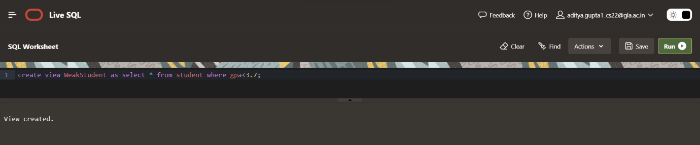

Q2. Create a view cView on college (containing all the columns) and rename the column cName as collegeName and enrollment as seats respectively.

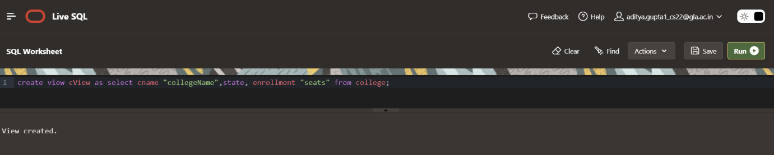

Q3. Create view CSaccept having IDs and college of student who applied to CS major and their application is accepted.

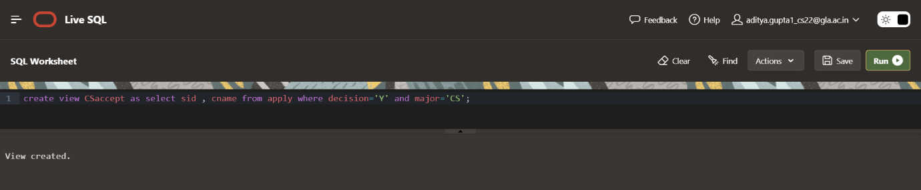

Q4. Create view CSberkeley having IDs, name, GPA, sizeHS of those student who are accepted in CS at Berkeley and comes from High School that is greater than 500.

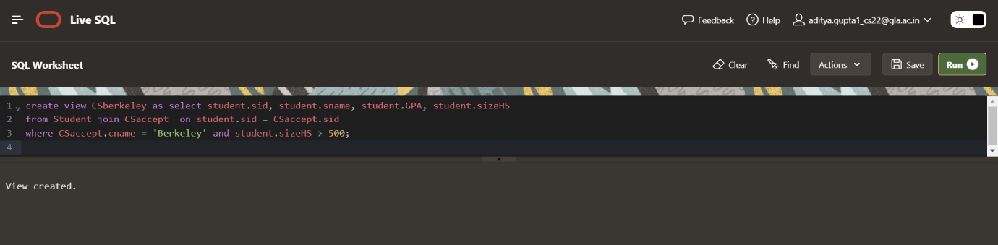

Q5. Display information about student in CSberk having GPA greater than 3.8.

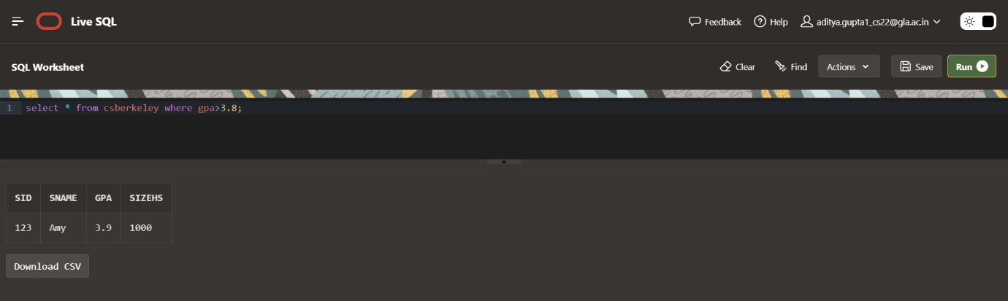

Q6. Drop view CSaccept.

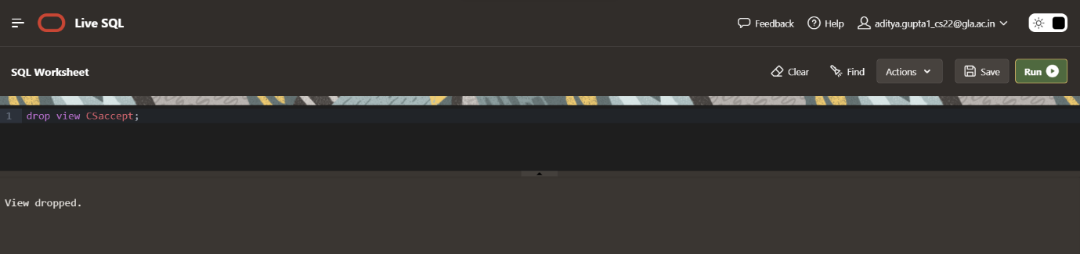

Q7. Display all student in CSberkeley.

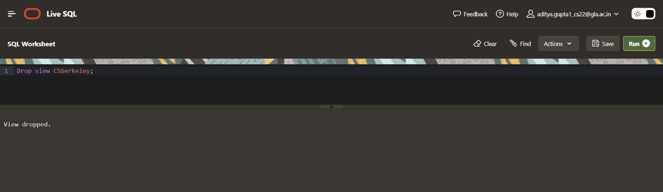

Q8. Update GPA by 0.8 of students in view WeakStudent who having high school size greater than 1000.

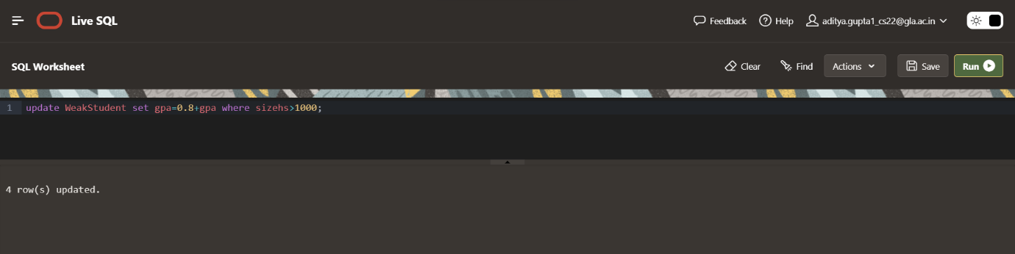

Q9. Create a view AppCount which contains sID of Student and number of applications they filed. Name the column sID and NoOfApp.

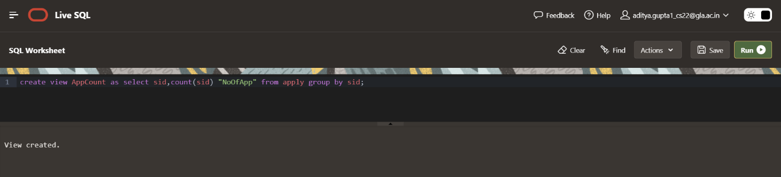

Q11. Create a view StuName contain student name and their GPA. Is this View Updatable? If not specify why.

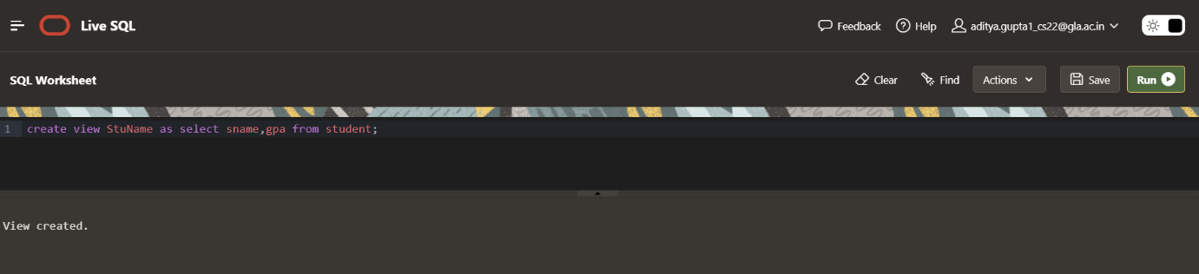

Q12. Create view studentHS having details of student comes from High School of size more than 1000 using with check option.

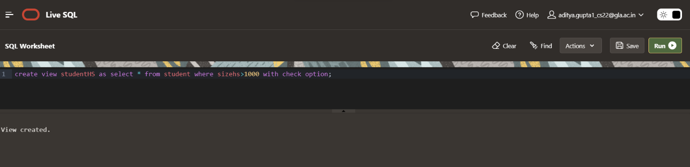

Q13. Try insert detail of a new student Ram with sID 999 having GPA 9.9 and sizeHS 9999 to newly created view studentHS.

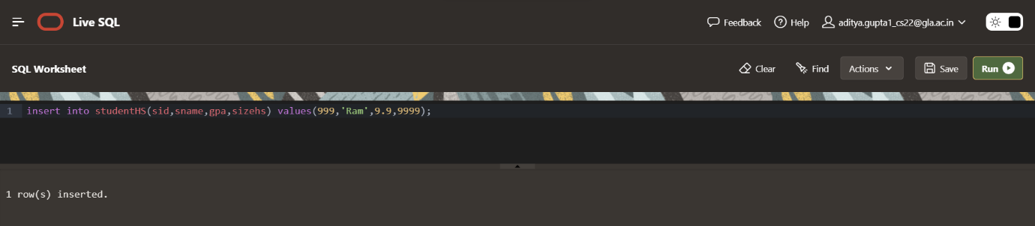

Q14. Clerk realize he wrongly type sizeHS of Ramu as 9999 it is actually 999. Can you help him to update the value of sizeHS of Ramu.

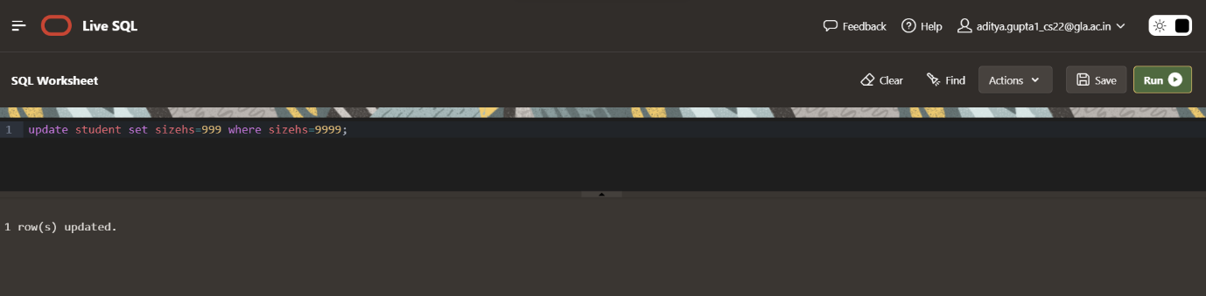

Q15. Now, another boy registered to our system named Ramu with sID 998 having GPA 9.8 and sizeHS 989.

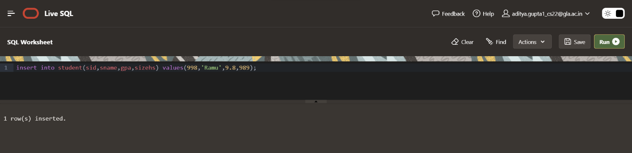

NAME 🡪 ADITYA GUPTA

SECTION 🡪 B

UNIV ROLLNO. 🡪 2215000094

CLASS ROLLNO. 🡪47